***REVISION OF GRADE 4 _ WEEK 23***

1. **Read the text and choose the best answer.**

**Paul is talking to his friend Jane.**

**Example**

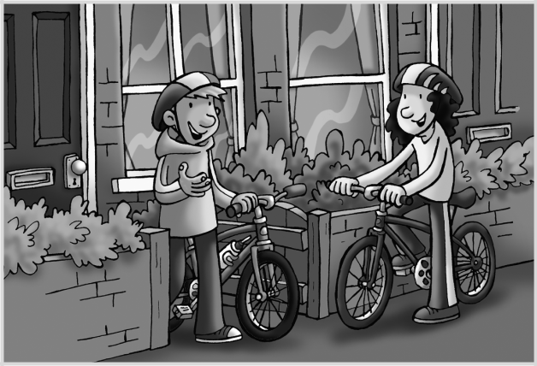

**Jane:** Hello, Paul! Whose bike is that?

**Paul:** A It’s in the garden.



1. It’s mine! It’s new.
2. Yes, it is.

**Questions**

**1 Jane:** Can I ride with you?

**Paul:** A All right.

B No, it’s with you.

C Yes, you are.

1. **Jane:** Did you go to the parkyesterday?

**Paul:** A At the park.

1. Yes, it did.
2. Yes, I did.

**3 Jane:** What was the weather like?

**Paul:** A Yes, I like it.

1. It’s sunny.
2. It was cloudy.

**4 Jane:** How is your sister?

**Paul:** A She’s at the cinema.

1. She’s fine.
2. She’s got brown hair.

**5 Jane:** I’m thirsty! How much water have you got?

**Paul:** A It’s a bottle.

1. No.
2. Lots! Here you are.

**6 Jane:** Do you want to come to my house?

**Paul:** A Sorry, I have to go home.

1. Yes, I do.
2. Yes, I don’t.



1. **Put the words in the correct column.**

bread  banana  fruit  lemon   apple  glass of water    rice  grape  water  coffee

**Countable nouns** **Uncountable nouns**

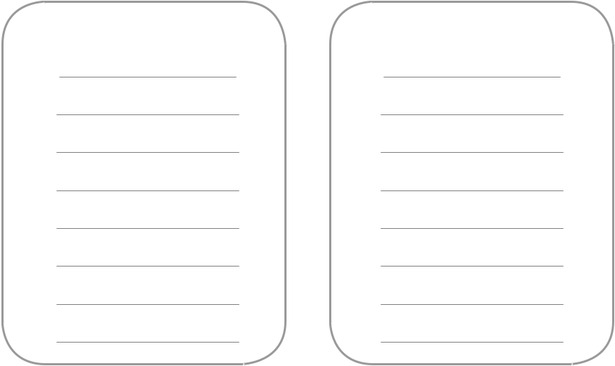

1. **Complete each phrase using a word from the box. Use each word once.**



some two some four some three

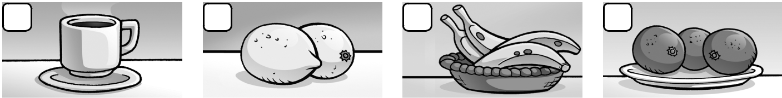

**1** **2** **3** **4**

some

coffee lemons bananas oranges

1. **Write *a*, *an* or *some.***

|  |  |  |  |  |  |  |  |  |  |
| --- | --- | --- | --- | --- | --- | --- | --- | --- | --- |
| **1** | an |  | apple | **2** | some |  |  | grapes |  |
| **3** |  |  | broccoli | **4** |  |  |  | glass of water |  |
| **5** |  |  | lemon | **6** |  |  |  | raisins |  |
| **7** |  |  | aubergine | **8** |  |  |  | rice |  |
| **9** |  |  | asparagus | **10** |  |  |  | orange |  |
| **11** |  |  | dates | **12** |  |  |  | fruit |  |
| **13** |  |  | banana | **14** |  |  |  | coffee |  |

aubergine (n): cà tím

asparagus (n): măng tây

dates (n): quả chà là

1. **Write affirmative sentences. Use *would like* and *a*, *an* or *some.***
2. Dad / grapes

Dad would like some grapes.

1. Charlie / bananas.
2. Molly and Harry / water

1. she / a glass of orange juice
2. 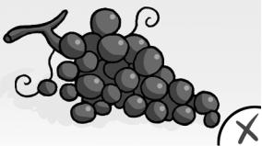**Look at the pictures. Write questions with *Would you like*. Then write the answers with Yes, please / No, thanks.**

Would you like some grapes?

No, thanks**.**























